     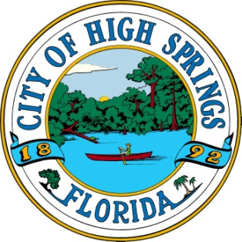

City of High Springs Telephone (386) 454-1416

23718 W US Hwy 27 Fax: (386) 454-5850

High Springs, Florida 32643 Web: highsprings.gov

Dear Local Business and Citizens of High Springs,

On behalf of the City of High Springs, I would like to thank you for your support in our youth programs. We are a growing program in need of supplies and are in search of sponsors for our youth leagues. We are looking to expand the program to involve local businesses. We want to create a close-knit community to help the City of High Springs develop together as a community and we ask for your partnership.

The team sponsorship fee of $375 helps the program provide the necessary equipment for the season. It also helps alleviate the league fee to ACTFOR which includes officials and insurance.

The High Springs Parks and REC department aims to ensure that no player is turned away because of financial need. We work to help families procure financial assistance so that their child or children can play local youth sports. Typically, league fees usually range from $65 to $90 per player; however, **ANY** financial assistance would be greatly appreciated.

We are proud of our community and the dedicated businessmen and women that support this effort.

Thank you for your continued support.

Sincerely,

Jennifer Applebee

Parks & REC Director

City of High Springs

**Sponsor Statement:** If interested, complete this form and submit a copy with an attached check made out to the City of High Springs to City Hall during the office hours of 8-5 Monday-Thursday

Sponsor Name: __________________________________________________

(Print as it would appear on the uniform)

Business Address: ________________________________________________

Contact Person/Phone Number:______________________________________

Team/Sport Preference:____________________________________________

Scholarship Amount($):_______

Questions? Email City of High Springs Recreation Department japplebee@highsprings.gov