Fall 2014 – KSC Recreation Soccer League
By Pat Robertson

On October 11, 2014, the tenth season of the Kokomo Soccer Club recreational league came to a close. This was a season of new faces for the KSC recreation league.
For the Fall 2014 season, the Recreation League had 304 players on 33 teams. Along with the players registered with the Kokomo Soccer Club, the NYO program was integrated for game play and for several administrative functions. NYO had 198 players on 23 teams. In total; 502 players comprised 56 teams.
The League also offered a referee training session before the season began and 11 referees attended this training. 72% of these referees officiated games during the season as assistant referees, and we also had 4 referees officiate their first game as center referees.
In all divisions, each team played at least eight games. At the end of the season each player was presented with a gold medallion with a black soccer lanyard.
In the U10 and U12 divisions, the season concluded with a single elimination tournament. Throughout the season each team played seven games and the results of these games determined the tournament seeding.
In the U10 division, the champions were the Mustangs (Orange Jerseys), coached by Chris Biggs. The runners up were the Gators (Green Jerseys), coached by James McConnell.
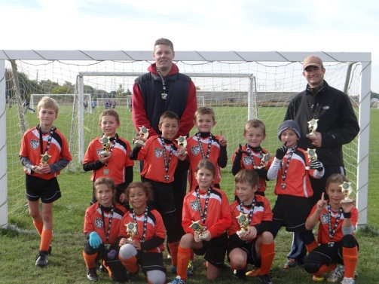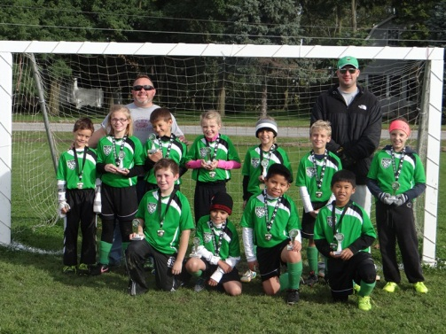
In the U12 division, the champions were the Tigers (Purple Jerseys), coached by Scott Spence. The runners up were the Blue Jays (Blue Jerseys), coached by Dan Rassel. We were also joined this season by a U12 team from the Taylor Soccer Club and for the first time a U12 team from the Tri-Central Soccer Club
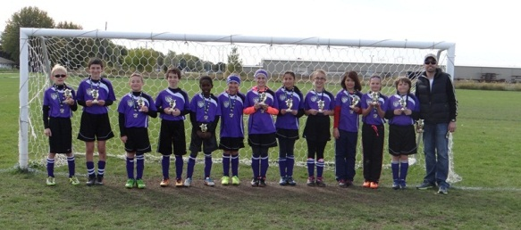
Our U15 teams played many competitive games. The KSC teams competed against a team from the Taylor Soccer Club and the Northwestern Middle School Girls team as well as normal interleague play between the KSC teams.
We look forward to beginning another recreational soccer season next spring. There is a wealth of information available on the KSC website for recreational soccer including registration information. Visit www.kokomosoccerclub.com/recreational for more details.

