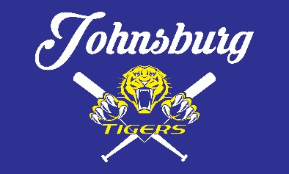

JOHNSBURG BOYS BASEBALL LEAGUE
  - 2026 SPONSORSHIP FORM

Our Mission
Fostering a love for baseball through teamwork, sportsmanship, and community engagement.

Sponsor Information
Sponsor Name: ____________________________________________
Street Address: ____________________________________________
City: ____________________________________________
State: ____________________________________________
Zip: ____________________________________________
Contact Person: ____________________________________________
Email: ____________________________________________
Phone: ____________________________________________
Website: ____________________________________________
Division Choice: ___________________________
(none, T-ball, Pinto, Mustang, Bronco, Pony)
Name(s) of Child(ren) in League:_______________________

Choose Your Sponsorship Level
Select | Level | Price | Benefits
☐ | Tiger Plus | $1900 | Logo on Rec Jerseys, Field Banner, Travel Team Banners, Social Media Posts
☐ | Tiger | $1750 | Logo on Rec Jerseys, Field Banner, Social Media Posts
☐ | Gold Plus | $900 | Logo on Rec Jerseys, Travel Team Banners
☐ | Gold | $750 | Logo on Rec Jerseys, Social Media
☐ | Bronze Plus | $650 | Logo on Sleeve &Travel Banners
☐ | Bronze | $500 | Logo on Sleeve
☐ | Silver Plus | $450 | Logo on Sleeve & Travel Banners
☐ | Silver | $300 | Logo on Sleeve
☐ | Travel Only | $500 | Logo on Travel Team Banners Only

Additional Options
Team Plaque: YES / NO
Table at End-of-Season Event: YES / NO

Terms & Agreement
Sponsorship supports JBBL’s mission and does not grant operational rights. Logos will be used for the 2026 season.
Authorized Signature: ____________________________________________

Deadline: March 15, 2026
Mail to: JBBL, PO Box 244, Ringwood, IL 60072
Contact: Amber Thornton | jbblsponsorship@gmail.com | 815-790-9591

