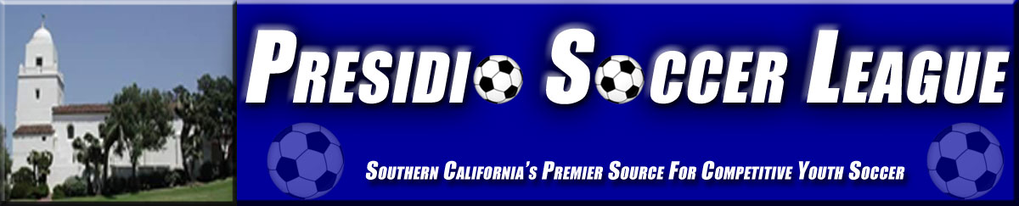

MATRIX COACHES WANTED
If you would love to coach All Star Level soccer all season, want to play club level at a discounted rate, determine what tournament you want to attend, then MATRIX is the program for you! Teams will play fall Presidio league and can participate in spring tournament seasons. Teams have an option to travel or participate at local tournaments.

WHAT IS MATRIX?
AYSO MATRIX is a competitive soccer program designed to provide a club level challenge for players who possess the appropriate interest, skills, and abilities. Players are selected through an evaluation process (Tryouts). The Program maintains the AYSO Core values that include: Positive Coaching, Good Sportsmanship, and Player Development. We focus on fun, teamwork, and developing strong soccer skills.

REGION 116 --‐ BONITA MATRIX PROGRAM
Bonita Region 116 Is pleased to offer the MATRIX Program in U11 to U19 divisions with all teams outfitted with a new look in Adidas. Coaches participating in the MATRIX Program are some of our most talented and experienced coaches. We are actively looking for experienced coaches.

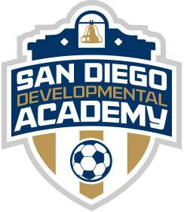
REQUIREMENTS
In Order to coach in the Matrix program, coaches have to: (We can help you with these)
• Be registered as a volunteer with AYSO Region 116
• Be Safe Haven certified
• Be an AYSO Trained coach one level above team age
• Be an AYSO trained referee
• Be In good standing with the Region, Area, Section and AYSO National
• Be Approved by the Matrix Coach Director Anthony Johnson and Selection Committee. anthony.johnson@cox.net
• Be evaluated and renewed each membership year
• Complete an MATRIX Coach Application form
- GET Started contact Vince Ortiz vicenteortizjr@gmail.com and Luis Corona luisayso@gmail.com for information. http://www.bonitamatrix.com/

Training: Coaches And Assistant Coaches Must have completed the following minimum training below, which may be satisfied after submitting the coach application as long as the certifications are obtained prior to the start of the season:
  - E-License U.S. Soccer Federation (USSF)
  - U11, U12: Intermediate Coach required, Regional Referee
  - U13 to U15: Advanced Coach required, Regional Referee

