Bartlett Little League Baseball Fundamentals

Throwing

Gripping the baseball
2 finger and 3 finger 4 seam grip
3 finger grip
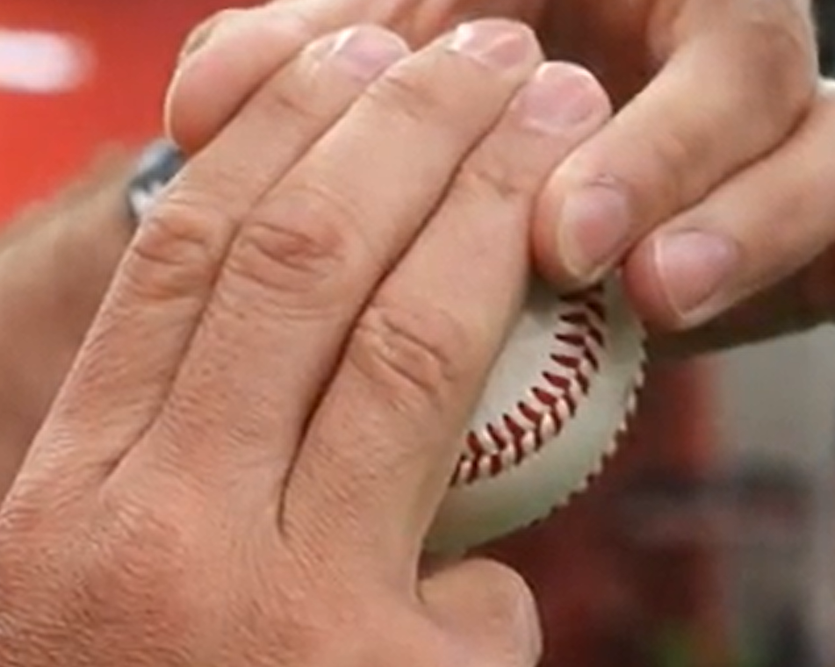
2 finger grip
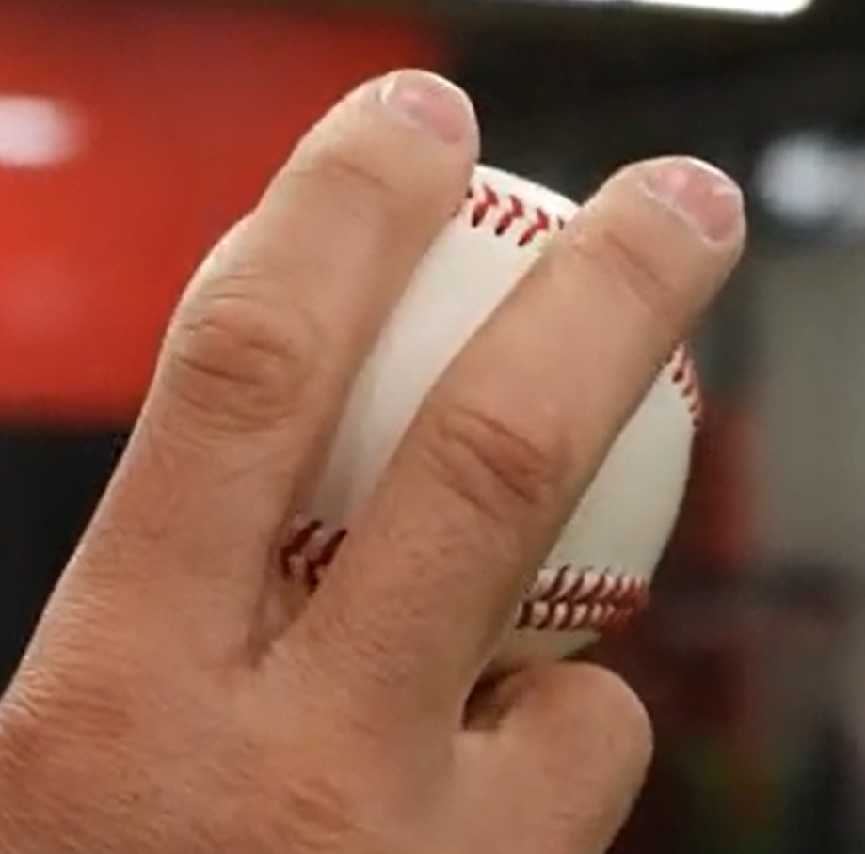
Thumb location
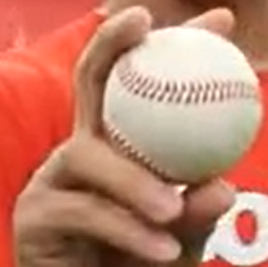

Throwing Checkpoints:
Checkpoints are our foot, knee, hip, elbow, and back of our glove. These checkpoints must face our target and must remain in a strong position throughout the throw. Glove and ball work in equal opposites

Circle drill
This drill is to combat bringing the arm up and stopping. It is important to have a smooth arm action when throwing. We don’t want there to be any stopping or hesitation when we throw. From the time the ball leaves our glove, we want it to be smooth free flowing. Looking from the side, we want our arm action to look like the letter “C”. This will give us the most time to accelerate our arm with less risk for injury. Depending on the position on the field will dictate how big the letter “C” is.

High Five Drill
This drill is to combat low elbows during throws.
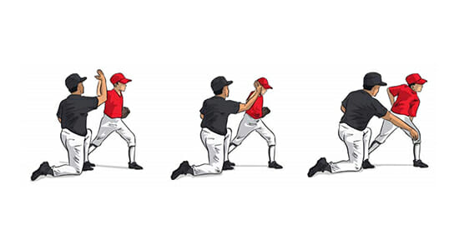

Throwing progression
A throwing progression is an important piece to every warm-up routine. As a coach, put your players in a straight line and have them partner up with another player. Starting out on a knee, from about 15 ft. focus on wrist flicks emphasizing back spin rotation on the ball.
After a minute, have them back up to about 20 feet and do “Rotational Throwing.” All 10 toes facing their partner, have them rotate from the waist up and work on their extension through their target.
After another minute, have them back up to about 25/30 feet and move on to the “Rock & Fire” (rock back and throw harder). At this point, their checkpoints are lined up with their target and they are focusing on weight transfer.
After another minute, have them back up to about 45 feet and shuffle and throw. From further distances, we want our players to move their feet to get some momentum into their throw.
The last step to the throwing program is “Quick Hands.” This drill focuses on using 2 hands and transferring the ball out of their glove as fast as possible.

Shuffle High Five drill
This is to combat receiving the ball and jumping up to throw from unathletic position.
Get player down in athletic position
Coach rolls ball to player
Player receives ball and hops up and lines up checkpoints
Player then shuffles back foot to front then shuffle front foot forward and gives other coach high five

Wall Drill
This drill combats short arm throws and encourages full motion throws
Stand kid arm’s length against a wall (home) or fence (fields)
Line up checkpoints
Have kid simulate a throw with ball (start with tennis ball then move to baseball) in hand
Make sure the kid touches the wall or fence with the ball

Fielding

Ready Position (prep step drill)
Have kid stand feet shoulder width
Coach then calls out a signal word(s) IE: READY POSITION or BASEBALL READY
Do the Right Left Hop (make sure the ball players are putting their weight on the balls of their feet and feet a little wider than shoulder width)
- Right leg out
- Left leg out
- Hop down
Make sure the ball players don’t have their elbows on their knees and they aren’t too far down. Make sure they are comfortable by having them stay in the position for a 10 count.
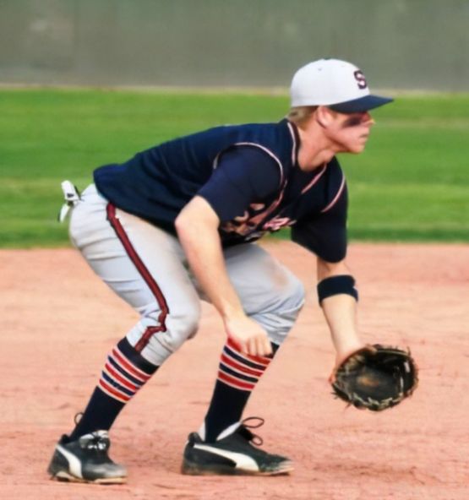
Younger ball players can do the sway. This is like the RLH drill, but they go from a normal standing position down to the balls of their feet with their feet with their feet a little wider than shoulder width and sway left and right with their glove down.

Fielding Triangle
Starting the drill, have the ball players in the ready position (in the dirt preferably) and draw a line from their left and right foot then finish the triangle out in front.
The fielding triangle is the position you want your players in when they are getting ready to field a ground ball. Their feet should be a little further than shoulder width apart, butt out, chest down and back flat. Our eyes should be down on the ball, with our hands out in front and palms up. The idea is to field the ground ball out in front, taking away the bad hop, with two hands. The ideal spot to field the ball is just inside the fielders left foot (or to the left of the top point in the triangle) allowing for a smooth transition into their footwork towards their target.
Minor change to enforce correct positioning to throw, move the triangle a little more to the glove side to promote faster checkpoint lineup as the glove will just need to move up with little left or right movement
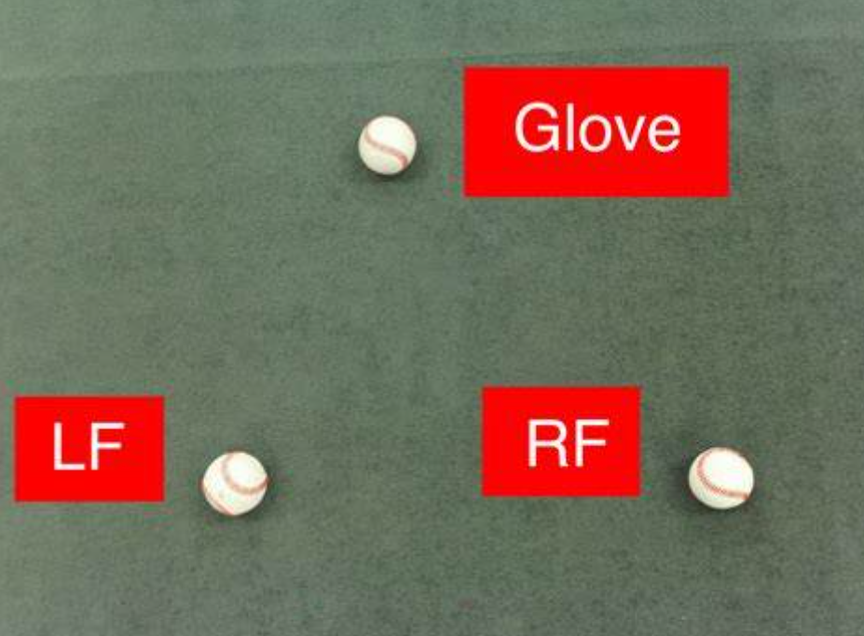

Box Drill
The box drill is a great drill to work on quick hands, quick feet, and good posture.
Drawing a box in the dirt or turf in front of the players, have them hop into the ready position or on each line around the box. They will hop or line up their checkpoints on the line to their left. Reset after each repetition and it will allow your players to reinforce the good habits of staying athletic and having good posture. This will take some practice to perfect and can be done with 3-4 players making 2-3 rotations around the square. Coaches in younger divisions need to be patient with this, the ball players will get it down.

Semi-Circle Bare Hand Drill
When teaching your players to field ground balls for the first time, it is always important to shrink the field and focus on the proper technique first. Have your players partner up, about 10 ft. apart and get down on both knees. Take a ball and draw a semi-circle in front of their body on the dirt. This semi-circle will be their reference point for where they want to field the ball. Using their bare hand, have your players roll the ball back and forth focusing on receiving the ball out in front of the semi-circle.

Semi-Circle Glove Drill
Progression from the bare hand drill. With gloves on, have the players up in their ready position utilizing the same motion of rolling the ball back and forth using their gloves to receive the ball. Coaches make sure the player has their glove in the dirt to eliminate the ball going under the glove and through their legs.

Pitching

Power T
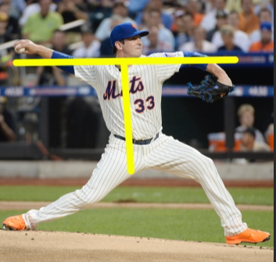

Basic Position
- The Setup:
This is the position where we get the sign from the catcher. As a pitcher, we want to line up our throwing side foot with the front of the rubber. After we receive the sign from the catcher, we will come “set.” This is where the ball is in our glove near the middle of our body, feet are about shoulder width apart and our eyes on the target.
- Leg lift and being balanced:
This is one of the most important parts of the pitching motion. After coming set, the pitcher will lift their front leg while keeping their head still and weight back. We must make sure that the foot stays below the knee to stay balanced. The leg lift should be slightly higher than the waist and the player should be able to stay balanced on the “posting” leg. Before moving towards home plate, the pitcher needs to drop down with their front leg instead of drifting/falling towards home plate to get their arm up in time.
- Separation:
After the leg lift, as we’re getting ready to move towards home plate, we’re going to separate our hands (with the thumbs down) to get into a power position (Power T). We’re going to lead with our lower half, keeping the weight back and keeping our shoulders somewhat parallel to the ground. Using “equal opposites,” (where the glove and hand break at the same time) we get ready to throw the ball to home plate. At foot plant, the ball should be facing the SS (for RHP) and 2B for LHP).
- Extension and Finish:
As we land with our front foot, we want to land soft and quiet. As we step, we want to land in a straight line towards home plate while our checkpoints in line with the catcher. As we throw the ball, our glove will tuck in towards our armpit and we need to emphasize getting extension towards home plate with our throwing arm. The chest should be out over the front knee instead of spinning off the mound and we should land in an athletic position, ready to field the ball.

Pitch Types
- 4 Seam Fastball: The Four Seam Fastball is the pitch that travels the straightest and with the most velocity. Have your players find the Letter “C” on the ball and place their pointer finger and middle finger across the C. We want to hold the ball loose in our fingertips with our thumb underneath the ball and our ring finger resting on the side of the ball. As the ball leaves the players hand, you will see all 4 seams as it spins.
Pictures are above under Throwing > Gripping the baseball.
- 2 Seam Fastball: The Two Seam Fastball is a different kind of fastball that players throw that has the tendency to move to the pitcher’s arm side when thrown correctly. Holding the ball in their fingertips, have the players find the spot on the ball where the 2 seams run parallel with the pitcher’s fingers. The pointer finger and middle finger should be placed between the seams and the last finger that touches the ball will be the middle finger. Making sure that the players wrist is cocked away from their body will create spin that will generate some movement away from the player and cause the ball to run as it travels to home plate.
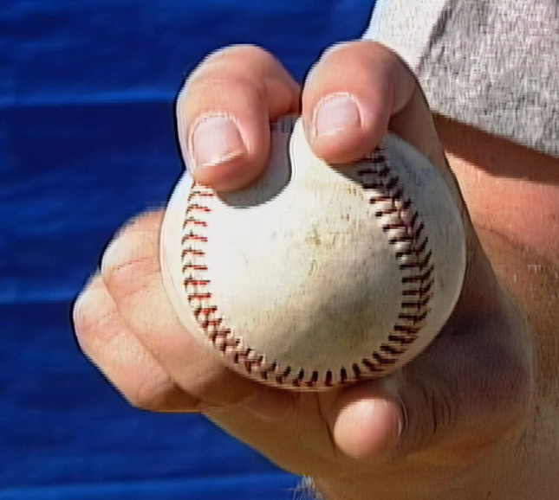 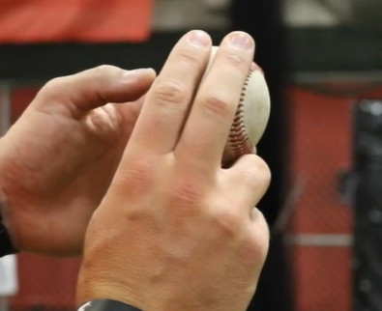 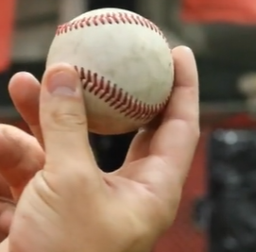
- Changeup: Instead of teaching younger players to throw breaking balls or curve balls, the changeup is a much safer alternative. Using the same grip as the four-seam fastball, slide the players middle finger and ring finger over the ball. The pointer finger should be on the inside of the ball and the pinky should be on the outside of the ball. Be sure to place the ball a little bit deeper in the hand. The grip and the extra friction on the ball will slow down the speed of the pitch. Make sure your players throw this ball hard, don’t attempt to slow down the arm but rather let the grip change the speed of the pitch.
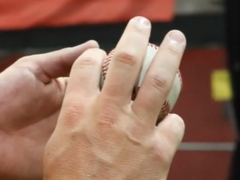 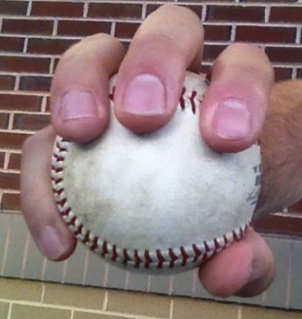

Picking off
The Step Off, The Pivot and the Quick Pick are the 3 types of pick off moves to keep the runner close to first base. During the step off, all the pitcher does is disengage their back foot from the rubber to let the runner know that we’re paying attention to them. We do not have to throw over in this situation. During the pivot, the pitcher must pop both feet at the same time, hopping off the rubber and turning towards first base. In this situation, the pitcher must throw the ball to the first baseman. During the quick pick, the pitcher will attempt to pick the runner off while they’re getting set. In most cases, they will catch the runner while they are either taking their lead or not paying attention while the pitcher is getting set.

Pitching Extension drill
The Extension drill is used for players that have a hard time finishing their pitches. Some pitchers spin off the mound, or land stiff using their front leg. Using the back of the mound, have the pitcher set up with their glove side foot (or plant foot) on the top of the mound while their posting leg (or arm side leg) is behind the mound. This will force the player to get their chest out over their front knee when they deliver the pitch to home plate. This will exaggerate the feeling of extension and make it much easier to get there when they throw on a flat surface or down the mound.

Base Running

Running through the base
Anytime your players hit the ball in the infield, it is important that we teach them to sprint through first base. A lot of younger players have the tendency to stop right at the base, slowing down before they get there. To give your players the best chance to beat the throw to 1st, they must accelerate through the base, touching the very front of the base – closest to home plate. After sprinting through, have them widen out their base (legs) to slow down and peek over their right shoulder to look for an overthrow.

Running through the base drills
- High Five drill
  - Coach 3-4 feet beyond the base
  - Base runner sprints through the base and gives coach a high five
- Run don’t look drill
  - Base runner set up in batter’s box and simulates a swing
  - Coach rolls ball in fair territory between mound and 1st base
  - Watch the runner
    - If the runner watches the ball correct the runner, or have the runner continue the run into the OF grass or to the fence
    - If the runner runs it correctly, extend praise to enforce the runner to continue

Rounding the base
On a base hit to the outfield, we as coaches must emphasize the importance of taking a hard turn around first - towards second base. This puts pressure on the outfielder to field the ball cleanly and puts your base runners in a position to take 2nd base on a bobbled ball. We always want our players to hustle and anticipate taking the next base. To do this properly, your player must create an angle before they get to 1st (make a banana turn) and hit the very inside corner of 1st base with whichever foot gets their first. An easy way to redirect the runner’s momentum towards second is have them tuck their left shoulder and get in a straight line with 2nd as fast as possible.

Rounding the base drill
- Set up a cone in the base path as a starting point of the turn.
- Set up another cone just to the foul side of the base path about 2-3 feet from 1st base
- Set up last cone between the 1st and last cone outside the basepath
- Line up kids 6-10 feet from first cone
- Have the base runner follow the line in the illustration
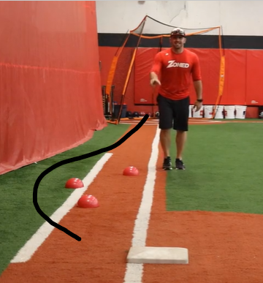

Tag Up drill
- Coach stands a few feet off the bag
- Base runner(s) is 2 hops from the bag
- Coach signals the ball is hit in the air
- Runner(s) sprint back to the bag
- Coach tosses ball in the air while kids watch the ball
- When the coach catches the ball runner(s) sprint to the next bag

Hitting inside corner drill
- Coach stands on back half of the base exposing where the runner should hit the base
- Runner runs towards the base and hits exposed part of the base
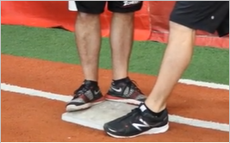

Base Stealing
When you teach your players to steal for the first time, first make sure they are in a good stance. As base runner’s we want to keep our eyes on the pitchers’ heels. If the front heel moves, the pitcher must deliver the pitch to home plate. If the back-heel moves, the pitcher is going to attempt to pick off. After about 3 or 4 steps, have the players peek in towards home plate to see where the ball is.

Hitting

Stance
We want to make sure our players are in an athletic and comfortable batting stance. We should have our players lay there bat down from their front foot and across home plate to make sure they have plate coverage as well as placing it down between their feet to make sure their feet are about shoulder width apart. Placing the bat just off their back shoulder, line their fingers up so that if they point their pointer fingers, they are both pointing towards the sky to ensure they have the proper grip. We want to make sure they are loose and relaxed, not stiff. Their knees should be slightly bent, and they should feel athletic standing in the batter’s box.

Loading
The load is the timing mechanism to make sure that the hitter is on time with the pitch. It is one of the most important pieces of hitting and so important to teach correctly. We want to picture a rubber band attached to the batter’s hands as well as the front foot. The idea is to stretch out the rubber band bringing the hitters hands back while they stride towards the pitcher. This will create “separation” and put them in a strong launch position. Another easy way to teach the load is to have them count out loud “1, 2, 3” and repeat the same cadence. The idea is to be smooth and in rhythm with the pitcher as they deliver the pitch. A loaded batter’s bat knob should be pointed towards the catcher.

Lower body
After getting loaded correctly, the lower half will start the swing and generate the power. Some coaches call it squishing the bug, but we must make sure that our players back foot/knee turn and drive towards the front leg, creating tension in the core/mid-section of the body. As their hips begin to fire, the back elbow should get tucked in and the barrel should follow connected to the back shoulder. (Tug of War position). This is the quickest and strongest path to the ball and will put your players in the strongest position to drive the ball.

Extension
After making contact, one common flaw that a lot of younger players make is that they don’t drive through the ball. Extension means to keep the bat in the strike zone for as long as possible after making contact. This will allow your players to generate back spin and produce more power. Most young players have the tendency to make contact and roll their hands across their front hip or not finish their swing. Tell your players to think “Palm up / Palm Down” after contact if they can.

Finish
The most important piece of the finish is to stay balanced. Using 1 or 2 hands, make sure your players stay balanced throughout the entire swing. The easiest way to teach your players to stay balanced is to have them take dry swings to be repetitive. A strong base is important in any swing, and we need to teach players at a young age to take a full, balanced swing.

Swing Path
It is important to teach young hitters to keep their barrel in the strike zone for as long as possible. The ideal swing is one that matches the plane of the pitch as it’s coming in. From the side, we want to visualize a Nike check or slightly uphill swing plane versus a “V” shape. The longer the barrel is in the strike zone, the bigger chance the hitter has to put the barrel barrel up the pitch.

Swing and Drop drill
This drill combats thrown bats after a swing.
- Coach should draw a square or place a bucket behind the batter
- Batter takes swing
- Batter puts the barrel of the bat into the square or bucket

Soft toss drill
This is an easy way to simulate a pitch. We want to make sure that we give the player time to work on their rhythm and timing. As coaches, take a knee or sit on a bucket and create a good angle for them to see the ball the entire time. We want to toss the ball towards their front hip/pocket to simulate the ball entering the hitting zone. Be sure to drop your hand slowly to give the hitter time to get loaded before they swing.
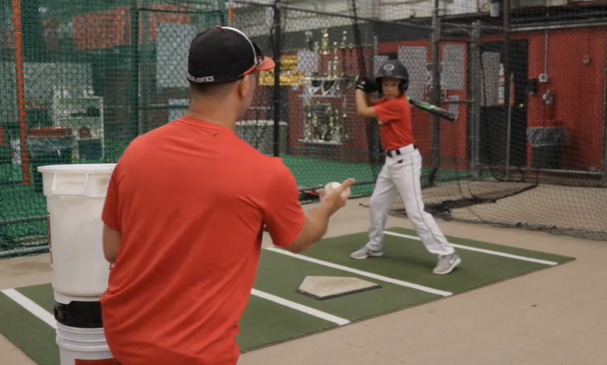

Tee drills
Many kids think they are too old to hit off a tee. It is important for coaches to utilize a tee to get swings in during practice. Set up the tee in different places around the front and front sections of home plate allows for the batter to get accustomed to hitting outside, inside, and middle pitches. Adjust height on the tee to simulate low and high zone pitches.

Hitting stations
During practices utilize stations of 3-4 kids per station.
- Soft toss
- Tee
- Hit stick
- No ball/dry swing

Catching – Catcher position

Safety
For first time catchers, it’s important to make sure that your players are safe and comfortable trying out a new position. Make sure that their equipment fits correctly, they are wearing their safety cups, and they are comfortable behind the plate.

Position
We want to make sure our catchers are in an athletic position, with the weight on the balls/inside of their feet. Their catching arm elbow/forearm should be resting on the front (not on top) of the catching side knee and the glove should be relaxed out in front. The throwing hand should be behind their back or behind their heel to protect it from a tip or non-caught ball. Make sure that the player lets the ball travel and “receives” the ball instead of stabbing at it.
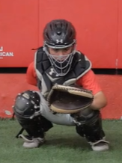

Signal Stance
This is the position that the catcher is in when they are giving the signs to the pitcher. We want the catcher’s legs to be close together, and we want the catcher to give the signs as deep (or as close to their cup) as they can to make sure the 1st base coach can’t see the signs. The catcher’s glove should hang over the left knee / shin guard of the catcher to keep the 3rd base coach from seeing the sign.
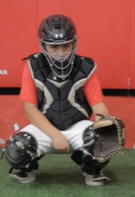

Catcher Blocking
We want to teach our players to block by leading with the glove. The shin guards and the chest will follow. The throwing hand should be hidden. The chest and back should be on an angle forward so that the ball deflects down, and the chin should be tucked.

Throwdown
Draw a straight line on the ground or put down a piece of tape. Young players tend to stand up too tall or drift towards 3rd base creating wasted movement. This line will give them a reference point to stride onto when getting ready to throw to second base. We want to make sure they hop into an athletic position, they let the ball travel and the create a short arm action to minimize wasted movement.
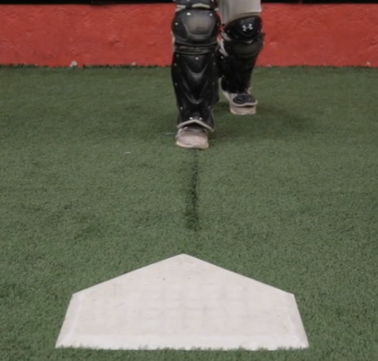 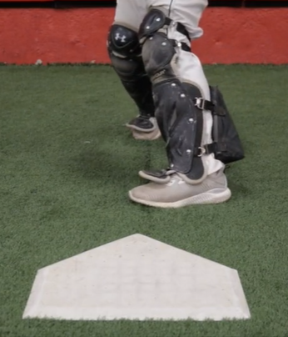 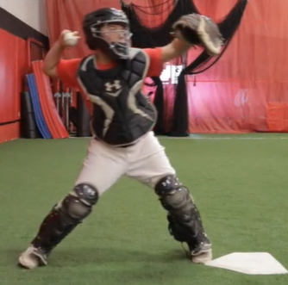

Pitch Reading and Recognition
Young catchers have a hard time reading the pitch. Some catchers don’t know when to block the ball and when to catch the low pitch. To help with pitch recognition, have a coach set up about 15/20 feet in front of home plate and mix up the pitches. Without telling the catcher what’s coming, have them start in their catching position to read the flight of the pitch and either block it or catch it.

