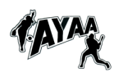

First Annual AYAA Golf Tournament

When: Sunday August 10th. 8AM Shotgun Start
Where: Apalachin Golf Course - South Apalachin Road
Cost: $220 / Team of 4 - $55/person
This includes Golf, Cart & Lunch!!!!

We are looking for hole sponsors!

For more information contact Trent Mercia - tmercia@stny.rr.com or 607-760-6324.

