WCYFL Coach Complaint Form
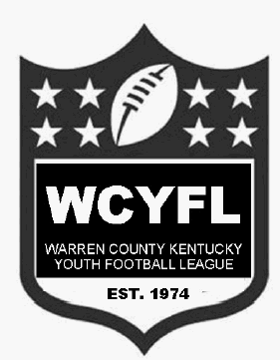

Coach’s Name: _________________________________
Team Assigned: ________________________________
Date of Incident: _______________________________

Nature of Complaint
- Please describe how the coach violated the Warren County Parks and Recreation Code of Ethics or exhibited behavior not in compliance with the WCYFL Mission Statement:
________________________________________________________________________________________________________________________________________________________________________________________________________________________________________________________________________________________________________________________

- Were there witnesses to the incident: Yes No (please circle one)
If yes, please include their names and testimony.
______________________________________________________________________________________________________________________________________________________________________________________________________________________________________________________________________________________________________________________________________________________________________________________________________

Please keep in mind that your contact information will be kept confidential

Complaint Filed By: _______________________________________
Contact Phone: __________________________________________
Email: _________________________________________________
Please print, complete, and provide form to the WCYFL league president for review. Email can be provided with call
2014 WCYFL President: Michael Littlefield 270-535-9474

