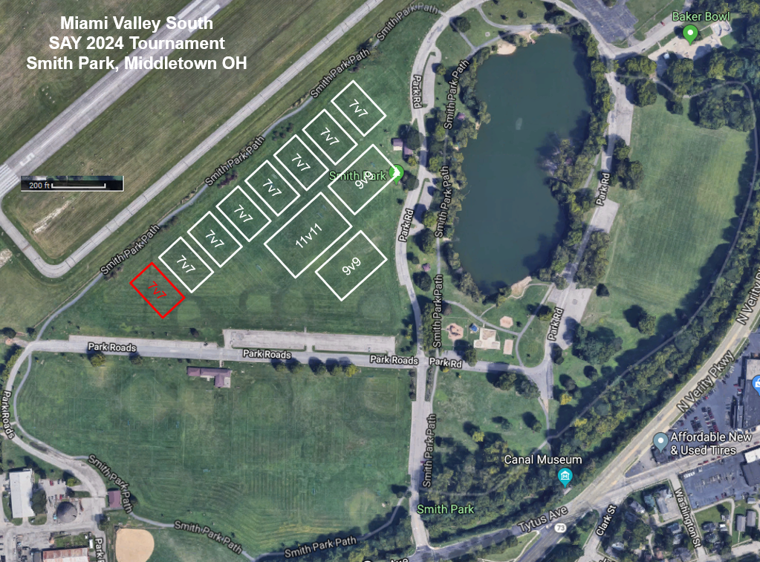



**SHOOTOUT**



Field Map Key

Fields 1,2,3,4- Passer

Fields 5,6,7 Wings

Fields 8,9 Striker

Fiels10 Kicker

Check In/Time Keeper

Shirt Tent



**8**

**10**

**9**



**7 6 5 4 3 2 1**

