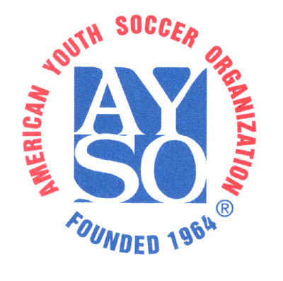 | Sponsored by Moorpark AYSO Region 363  2016 Apricot Jam Soccer Tournament  Youth Referee Authorization Letter | 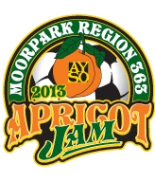

Youth Referee Name:
Current Age |  | Date of Birth:
AYSO Badge Level: |  | Certification Date:

Youth referees must carry a copy of this letter with them at all times and present it to any Tournament Officials upon request. Youth referees also must either have a parent/guardian present at all times, or must have a copy of their Youth Volunteer Registration Form attached to this Letter.

- The Apricot Jam Soccer Tournament requires that Youth Referees have this letter of authorization from their respective Regional Referee Administrator, certifying that they are skilled and experienced to handle the rigors of a competitive tournament game.
- The Apricot Jam Soccer Tournament further requires that the Youth Referee be at least 2 years older than the age group for which they are officiating and further that they are not a player on a team that is currently entered in the Apricot Jam Soccer Tournament

Regional Referee Administrator Information:
Regional Referee Administrator’s Name |  | Phone Number |  | Email
I understand that a highly competitive tournament like the Apricot Jam Soccer Tournament generates a great deal of excitement and rigorous play that present a unique challenge to any referee. As a youth referee, there is an increased level of challenge due to the scrutiny that a youth referee is subjected to.
Nevertheless, I certify that this Youth Referee is a member in good standing from my Region, that s/he is skilled and experienced to referee games up to the level indicated below, and that s/he is at least 2 years older than the age group indicated:

 | GU-10 | BU-10 | GU-12 | BU-12 | GU-14 | BU-14 | Badge | Cert date
Skill level as a Referee (check all that apply)
Skill level as an Assistant Referee (check all that apply)

RRA Signature and date (Blue ink please)

