
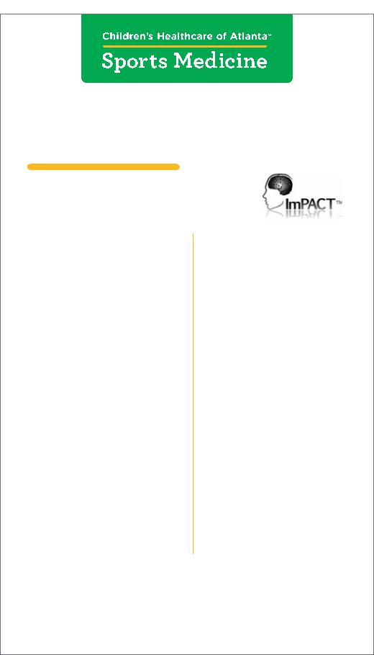
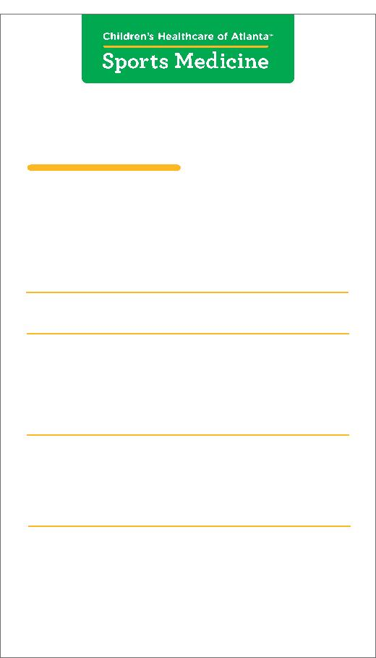
Concussion Sideline Reference Card
Sideline evaluation for coaches and athletic trainers
Concussion
Signs and Symptoms Evaluation
Sideline
Cognitive Testing
404-785-1111
choa.org/concussion
404-785-1111
choa.org/concussion
Signs observed by staff
Symptoms reported
by athlete
Ask the athlete the following questions:
• Appears dazed or stunned
What city is this?
What month is it?
What day is it?
• Headache
Who is the opposing team?
• Confused about assignment
• Forgets plays
• Nausea
Ask the athlete to repeat the following three words:
• Balance problems
• Dizziness
Girl, dog, green
• Is unsure of game
or opponent
Ask the athlete the following questions:
What happened in the prior quarter/period?
What do you remember just prior to the hit?
What was the score of the game prior to the hit?
Do you remember the hit?
• Double vision
• Fuzzy vision
• Moves clumsily
• Answers questions slowly
• Sensitivity to light or noise
• Feeling sluggish
• Loses consciousness
(even temporarily)
• Shows behavior or
• Feeling foggy
Ask the athlete to do the following:
Repeat the days of the week backward (starting with today).
Repeat these numbers backward:
personality changes
• Change in sleep pattern
• Concentration problems
• Memory problems
• Forgets events prior to hit
(retrograde amnesia)
63 (36 is correct)
419 (914 is correct)
• Forgets events after hit
(anterograde amnesia)
Repeat the three words from earlier:
Girl, dog, green
Symptoms may worsen with exertion.
Athlete should not return to play that day and must be
cleared by a physician before returning to activities.
Any failure should be considered abnormal.
The athlete should not return to play until cleared
by a physician as a concussion may have occurred.
In case of an urgent concern or emergency, call 911 or go to the nearest emergency department right away.
©2013 Children’s Healthcare of Atlanta Inc. All rights reserved.SPM 954349.mv.8/13
©2014 Children’s Healthcare of Atlanta Inc. All rights reserved.
7
choa.org/concussion

