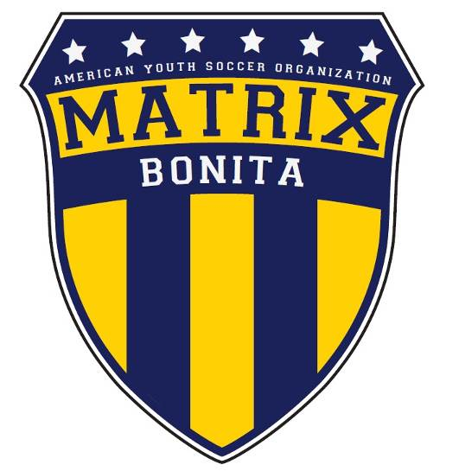
Pre-Season Letter to Parents
Dear Parent:
Welcome to Bonita Matrix of AYSO Region 116. Your child has tried out and has been selected to play in our soccer club in a more challenging environment. This program will allow players with similar abilities and skill development to play in more competitive games.
One of the factors critical to the success of the program is sideline behavior. Bonita Matrix has clearly defined expectations for spectators. Please read and follow the Parents Code of Conduct. This program needs the combined positive efforts of all participants to be successful. This form is to be completed and returned prior to your child attending his/her first practice or to the Parent Orientation meeting, whichever is sooner.
Return to: _____________________________________________________________
If you have any questions regarding this program, please contact our Director of Coaching (Anthony Johnson) at: anthony.johnson@cox.net

Sincerely,

Coach John/Jane Doe

 Do not force an unwilling child to participate in sports

Remember, children are involved in organized sports for their enjoyment, not yours

Teach your child always to play by the rules

Teach your child that hard work and an honest effort are often more important than a victory

Help your child work toward skill improvement and good sportsmanship in every game. Your child will then be a winner, even in defeat.

Do not ridicule or yell at your child for making a mistake or for losing a game.

Set a good example. Children learn best by example.

Applaud good plays by your team and by members of the opposing team.

Do not publicly question referee judgment and never their honesty.

Recognize the value and importance of volunteer coaches, administrators and officials and give them respect. Without them, there would be no Matrix Soccer.

Support all efforts to remove verbal and physical abuse from youth sporting activities.

Let the coach(s) coach, parents cheer, and the children play.

I have read and understand the Bonita Matrix Parent’s Code of Conduct
Parent Signature ______________________________________ Date ________________

Player Name __________________________________
Coach Name __________________________________
Region: ___/___/___ Division _________Boys/Girls

