**MRPGS Girls Softball League**

**Softball Rules and Guidelines**

**Starlets 6-8 Year Old Home League**

The Starlet level is structured as a clinical league, and its primary objective is to further educate children in the fundamentals of softball, sportsmanship and to prepare them for the next level of competition.

* Supplied Equipment:
  + Registration fees include uniforms consisting of a softball shirt, visor, shorts, and socks. The following equipment is supplied by the league and are made available for use during games and practices.
    - Softball Bats
    - Batting Helmets (Personal helmets are permitted)
    - Catcher equipment
    - Batting tees and balls
    - Softball Pink 10” soft
* Mandatory Equipment:
  + Footwear: Rubber cleats are required. Metal spikes or sneakers are NOT permitted.
  + Softball mitts are required
  + All players must be in full uniform
  + Heart guard
* Recommended Equipment: (Any personal equipment please LABEL with child’s name)
  + Water bottles
  + Bat bag

GAME GUIDELINES

* There are no standings and playoffs.
* Umpires are not used in Starlets. The coach nearest to the play makes the call of out or safe.
* A 2 hour time limit shall be imposed if a subsequent game is scheduled.
* All games are six MAX (6) innings. There will be no extra innings in the event a game ends in a tie.
* Bases are to be placed 40 feet apart.
* Pitching is from 23 feet. If coach pitch, you can move up closer to make it easier for the kids to hit.
* Stopping the game for instructional purposes is highly recommended.

PITCHING

Coach Pitch (opening day to May 1)

* There are no walks or for coach pitched innings.
* A strikeout will result from three (3) swinging strikes. If kids are taking strikes it should be pointed out to them and encourage them to swing.

Kid Pitch (May 1 and beyond)

* KIDS will pitch first 3 innings and then coaches pitch last three.
* There is no walking, upon five (4) thrown balls the coach will jump in and pitch to their team. A strikeout will result from three (3) called or swinging strikes. The objective is to keep the game moving. The coach will be behind the batter and should call strikes.
* There are no balks.

FIELDING

* A player will play the position of catcher, with a coach as backup.
* Play will stop when the ball is thrown into the vicinity of the pitching coach.
* Teams can play 10 players. (Note: don’t place extra girl on second base, play 4 outfielders, this way it promotes the 2nd and shortstop to cover the bag).
* Coaches are encouraged to move players around to various positions during the game.
* Infield fly rule will not apply.

HITTING

* NO Tee will be used at this level.
* NO Bunting.
* The batter will be allowed 3 strikes and balls will not be counted. If the batter is not swinging at strikes, she will be warned and the next pitch in the strike zone and not swung at, will be counted as a strike.
* The team at bat will be allowed 3 outs or a maximum of 5 runs per inning.
* All players will be in the lineup to hit.

RUNNING

* Sliding is allowed for plays at 2nd base, 3rd base, and home plate.
* 1 base on an overthrow, only on plays to 1st base.
* Stealing is not permitted, however encourage the kids to get of the base (secondary lead) after pitcher releases the ball.

COACHING

* All coaches and assistant coaches must be RUTGERS certified, Concussion Trained, and Background Checked.
* A coach is allowed to stop the game for instructional purposes.
* Defensive coach’s are allowed on the field. Typically one behind 2nd base and shortstop (3 max allowed on field at once)
* The offensive team can have a maximum of 4 coaches on the field; Pitcher, behind catcher, 1st and 3rd base coaches.
* Coaches are responsible for leaving the field in a clean and orderly fashion and for securing and locking all league furnished equipment after the game.
* Coaches must be responsible for the conduct of their team and must ensure that they act appropriately.
* Kids should remain on the bench if they are not of the field.
* Parents are not allowed in the dugout.
* Have a lineup and position chart ready for each game, keeps them involved and teaches them locations.

PRACTICE

* Goal is to keep them moving and active.
* Goal is to get as many swings, ground balls, fly balls as possible. Repetition is key.
* Hitting
  + Break up into stations with 3 or 4 kids per group.
  + Tee station,

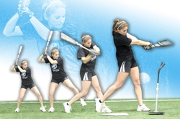

* + Tee station
  + Soft toss from side, drop from above, or soft toss from behind.

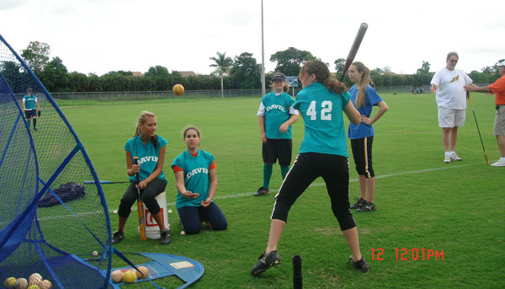

* + Live pitching
  + Throwing
    - Wrist flip

http://www.fast-pitch.com/images/wrist_snap.jpg In the position shown above, rest your forearm on your thigh. Extend the wrist and throwing hand out over the knee.

b) With a fastball grip, cock and snap your wrist to throw the ball straight upward. You may initially hold your forearm down with the other hand to ensure that only the wrist muscles are used, but eventually you must learn to do this drill by relaxing your forearm during the wrist snap,

c) You may use any ball but a weighted softball, like a 1 pound cannonball which can be purchased on-line, is best.

d) Work on increasing the height of the ball as it is thrown (ball speed) and work on controlling where it lands (ball control).

The benefits of this drill are it helps increase ball speed with better wrist snap, improves control by practicing ball release and it corrects improper release.

You should feel the ball roll off the ends of the fingers, feel the laces on the ball as it is released and you should relax your arm muscles as you flick your wrist.

* + One knee throw
    - Eliminates extra leg and body movement, concentrates on arm position.

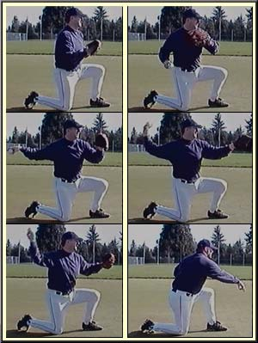 

* + Proper over hand throwing technique, 4 steps.
    - Balance
    - Step towards target
    - Glove out, throwing hand back with 90 degree elbow, ball away, lead foot pointing towards plate/player, weight on back leg
    - Follow through arm across body back leg comes around lands in front of other foot.

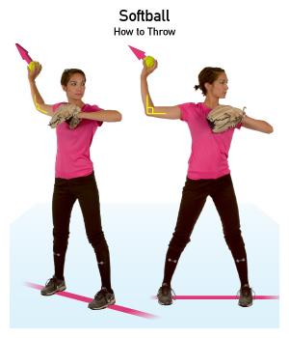

* + Proper Windmill pitching
    - It is never too young to practice proper windmill pitching technique.
    - Start simple with no leg kick just up and around with feet on ground.

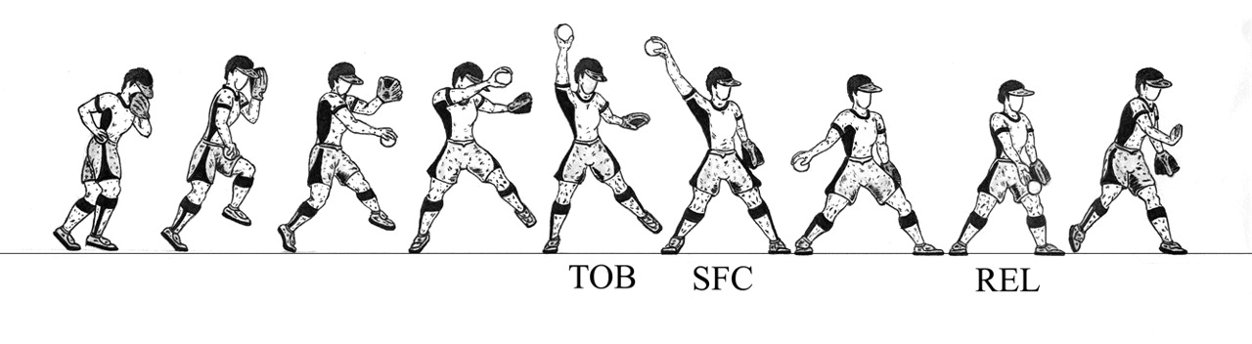

* Fielding
  + Break up into stations with 3 or 4 kids per group
  + Have 3 kids at each infield position with 4 coaches on infield, have one coach hit to each group and throw back to them. Rotate kids every ground ball and then rotate the position.
  + Work in more challenging fielding.
    - Hit to SS throw to 3rd.
    - Hit to 2nd throw to 1st.
      * First baseman to bag, big target.
    - Double play ball 2nd to SS.
  + Situational fielding (use extra kids as runners)
    - Runner on 1st and 2nd
    - Runner on 2nd
    - Base loaded
  + Cutoffs
    - SS out for left and center field hits
    - 2nd out for right field hits
  + Fielding position
    - Glove open, down on ground and alligator mouth.
    - 2 steps forward towards batter on pitch
    - Backing up, cover your base,

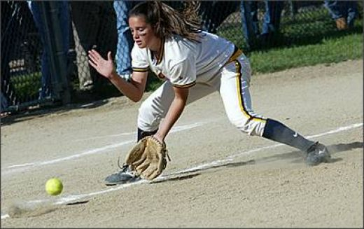

* Running
  + Home to first
    - Overrun the base into foul territory
  + Home to second, make proper turn

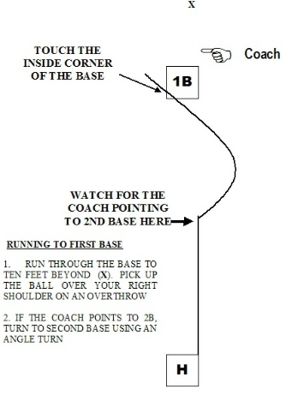

* + 1st to 2nd or 2nd to 3rd
    - Run hard, cannot overrun
    - Proper stance facing next base you are running to.

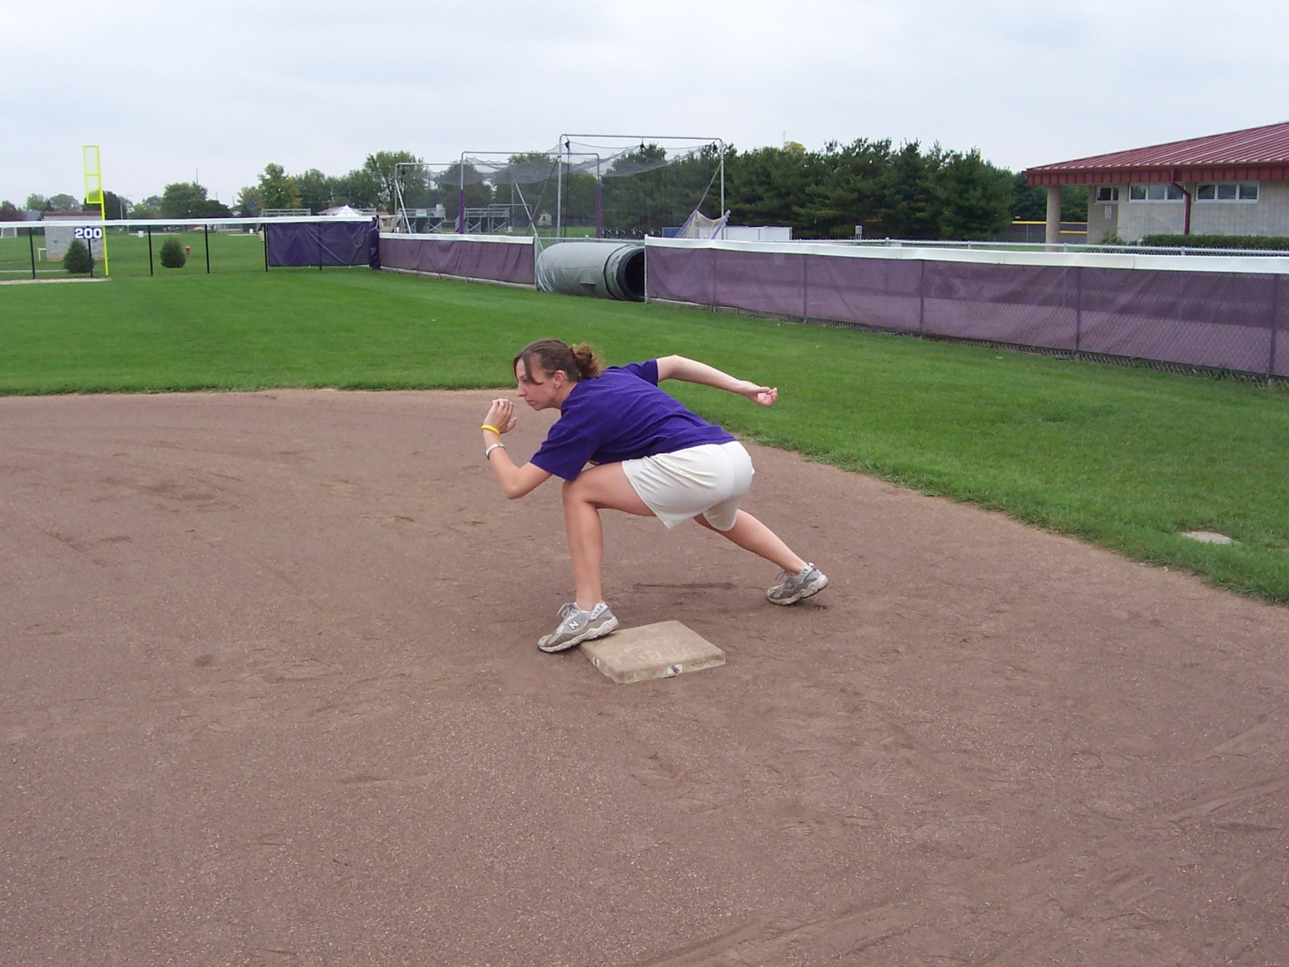

* + Sliding
    - On side of thigh, front leg up so you don’t jam your foot. Hands up.

