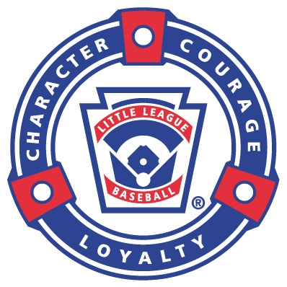
LOLLL Board of Directors Meeting
August 10, 2015
Phoebe Griffin Library-Community Room

Meeting called to order at 6:38 PM by Kim W.
Those in attendance and constituting a quorum were:
Attended by Non-Attendees
President Kim Warecke Registrar Kyle Snurkowski
Vice President Tom Richardson Safety Officer Doug Andrews
Concessions Gigi Andrews Coaching Director James Deberardinis
VP Coach Pitch/Instructional Larry Porter Sponsor/Fundraising Mgr Mike Lech
Treasurer Lynn Porter Equipment Manager Mike Guillet
Secretary Melynda Guillet VP Girls Majors/Minors/CP Jason Lathrop
Information Officer Carl Roth P Boys Majors/KP Erin Wyman
Player Agent Matt Ward
V Registrar Kyle Snurkowski

Old Business
- Approved Minutes from 6/10/2015 LOLLL Meeting: Approved ;motion was seconded and approved
- Excellent 2014/2015 LOLLL season!

Open Items:

Action Items:

- Mike G is still needs remaining equipment from teams.

New Business

- Mike L resigned moving out of area.

Open Items:
- Plaque to be purchased and hung for the 11/12 Sutura Tournament Winning Team: Approved ;motion was seconded and approved
- Discussion of BOD positions for 2015/16; reduce the amount of VP’s to 3
  - Baseball/Softball/Instructional
  - Add a Website Master/Scheduler
  - Add a Purchasing Agent-eliminate Equipment Manager
  - Add Field Manager-eliminate Information Officer; need someone who can oversee all fields and determine funds to spend on all fields and schedule work days to ensure all fields represent our league
  - Net 15 BOD Positions in line with 2014/15

- Determine who is interested in staying on next year for BOD: Mike G, James D, Matt W, Tom R, Melynda G, Kyle S, Carl R, Lynn P, Kim W and waiting to hear from Jason L.
  - Each current BOD member expressed interest in the capacity in which they would be interested in working for the upcoming season; the BOD roles will go up for vote at the Annual Meeting held in September prior to the new fiscal year October 1, 2015.
  - Interest:
    - Kyle-Registrar
    - Mike-VP Boys
    - Matt-VP SB
    - James-Coaching Coordinator
    - Tom-Fundraising
    - Melynda-Communications
    - Carl-Field Maintenance
    - Lynn-Treasurer
    - Kim-President
    - Jen Fallon-Purchasing Agent
    - John Sahadi-expressed interest in joining the BOD

Action Items:
- Fall Ball starts soon – need to send out communication to league : Melynda G
- Library works well; schedule future meetings
- Field clean up and close up concession day Wednesday 8/12/2015-clean and take down banners
- Email league to gather community interest in BOD remaining vacancies for 2015/2016 : Melynda G.
- Little League International recommends that the outgoing BOD updates and recommends changes to Bylaws prior to new BOD :
  - Kid Pitch –add another tier
  - Kid Pitch- clear expectations and consistent rules with East Lyme
  - All Stars teams 9/10 and 11/12
  - Make-up date is needed for try- outs
  - T-ball have meet and greet day prior to opening day
  - Pictures on opening day
  - Registration to be completed on line for new players with live sign ups as well
- Scheduling LOLLL Town Hall 9/21: Carl R. connect with Marcia from region 18

Treasurer’s Reports
Open Items:
Budget update
Approximate $2k concessions net earnings after expenses
$23k left in account to date

Action Items:

VP Reports

Calendar for upcoming year:
SCHEDULE FOR THE YEAR:
- 9/15/15 BOD Meeting: Teddy’s back room
- 9/21/15 Town Hall : LOL Middle School Auditorium

AGENDA TOPICS:
- Approve Minutes
- Prepare Ballot for BOD
- Review updated by laws

Meeting adjourned 7:57 PM EST.
To add additional Agenda Topics please email Melynda Guillet at mg11@netzero.net

